


METHOD OF PROCEDURE
VERIZON WIRELESS
MODIFICATION;5G_L-Sub6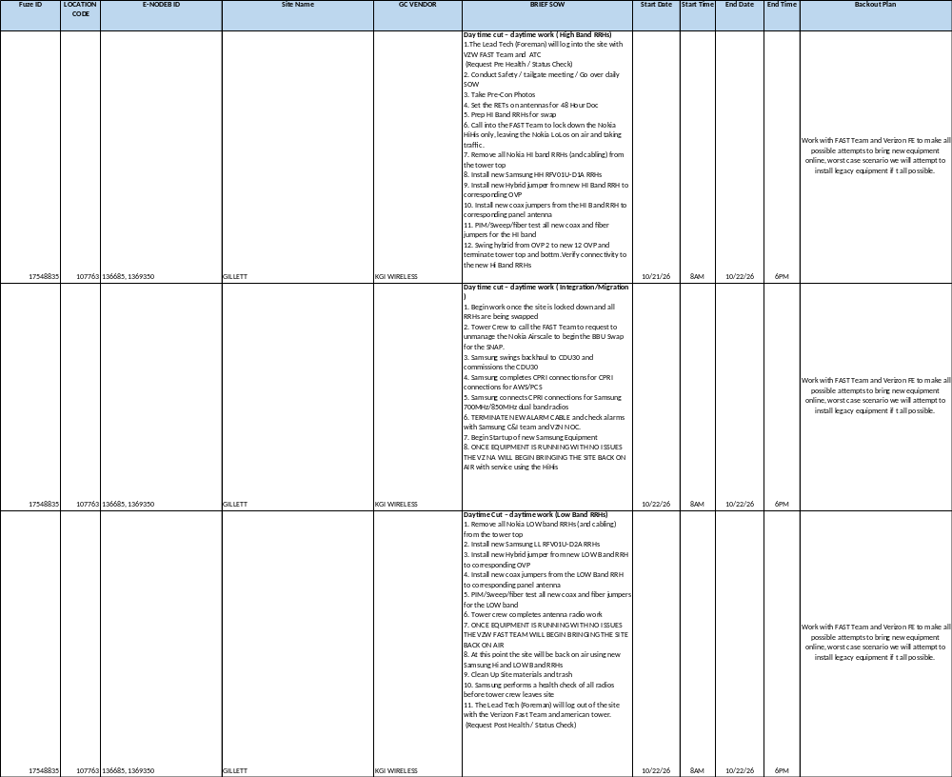
- EQUIPMENT

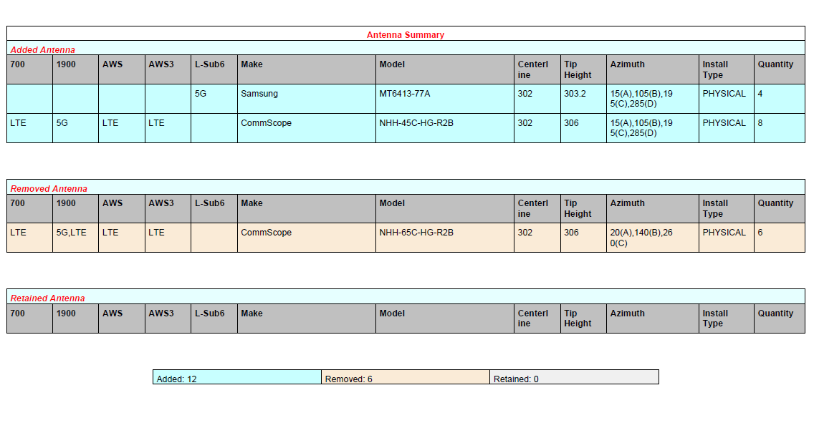

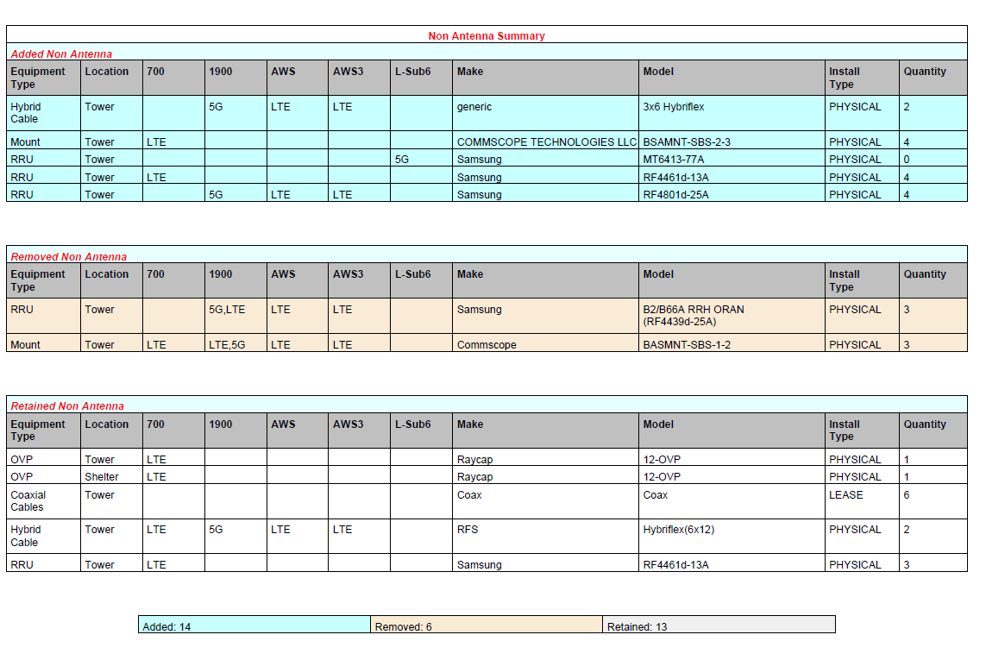

- PERSONNEL
- Marin Maximciuc(Foreman): 469-478-0499 (Onsite Lead - KGI)
- Ronny Rodriguez (Project Manager) 210-632-3354 (Off Site Contact - KGI)
- Evan Herkert (Project Manager): 469-955-1264 (Off Site Contact-KGI)
- Henry Little (VZW Field Tech): 361-244-0693
- Donald Bourque (VZW NA Manager): 361-563-0061
- Broc Reynolds (Construction Engineer): 817-779-2772

ALL EMPLOYEES WILL BE INSTRUCTED TO THEIR SPECIFIC TASKS PRIOR TO INSURE SAFE PRACTICES IN THEIR DEDICATED TASKS. PROPER PPE TO EACH TASK WILL BE IMPLEMENTED.
ie
SAFETY GLASSES WHEN DRILLING
HARD HATS WHEN OVERHEAD WORK IS BEING PERFORMED
FALL PROTECTION WHEN WORKING ON THE TOWER
PROTECTIVE GLOVES WHEN HANDLING EQUIPMENT

- DETAILED STEP-BY-STEP PROCEDURE

LEAD PERSONNEL WILL CONTACT OPS 24HRS PRIOR TO PROJECT

CREW WILL ARRIVE AT LEAST AN HOUR BEFORE SITE IS SCHEDULED TO BE SHUT DOWN FOR PROJECT

UPON ARRIVAL LEAD TECH WILL LOG INTO IVR, AND Call VZN FAST Team

LEAD TECHS WILL BEGIN INSPECTING EXISTING EQUIPMENT FOR ANY PRIOR ISSUES

LEAD TECHS WILL SURVEY THAT THE NEW UPGRADED EQUIPMENT WILL NOT HAVE ANY CLEARANCE ISSUES WITH EXISTING SITE CONDITIONS AND/OR EQUIPMENT

Day One of Tower Work – Day Time Work
- The Lead Tech (Foreman) will log into the site with VZW FAST Team and American Tower.
- The Lead Tech (Foreman) will make the determination to move forward with the project based on the crew’s ability to successfully complete the project, including the weather and safety conditions onsite.
- The Tower Crew will prep all equipment and modification materials.
- The Tower Crew will capture all preconstruction photos and documentation required.
- The Tower Crew will rig the tower as needed to complete the SOW.
- The Lead Tech (Foreman) will log out of the site with the VZW FAST Team and American Tower
- The Lead Tech (Foreman) will log into the site with the FAST Team and American Tower.
- The Lead Tech (Foreman) will make the determination to move forward with the project based on the crew’s ability to successfully complete the project, including the weather and safety conditions onsite.
- The Lead Tech (Foreman) will log into the site with the VZW FAST Team and American tower
Day Time Cut – Daytime work ( High Band RRHs)
- The Lead Tech (Foreman) will log into the site with the VZW FAST Team (Request Pre Health / Status Check)
- Conduct Safety / tailgate meeting / Go over daily SOW
- Take Pre-Con Photos
- Prep HI Band RRHs for swap
- Notify the FAST Team to lock down the Nokia HiHis only, leaving the Nokia LoLos on air and taking traffic.
- Remove all Nokia HI band RRHs (and cabling) from the tower top
- Install new Samsung HH RFV01U-D1A RRHs
- Install new coax jumpers from the HI Band RRH to corresponding panel antenna
- PIM/Sweep/fiber test all new coax and fiber jumpers for the HI band
- Verify connectivity to the new Hi Band RRHs
- The Lead Tech (Foreman) will log out of the site with the VZW FAST Team.

Day Two of Tower Work – Day Time Work

Day time Cut – Daytime work ( Integration / Migration )
- Begin work once the site is locked down and all RRHs are being swapped
- Tower Crew to call the FAST Team to request to unmanage the Nokia Airscale to begin the BBU Swap for the SNAP.
- Samsung swings backhaul to CDU30 and commissions the CDU30
- Samsung completes CPRI connections for CPRI connections for AWS/PCS
- Samsung connects CPRI connections for Samsung 700MHz/850MHz dual band radios
- TERMINATE NEW ALARM CABLE and check alarms with Samsung C&I team and VZN NOC.
- Begin Startup of new Samsung Equipment
- ONCE EQUIPMENT IS RUNNING WITH NO ISSUES THE VZ NA WILL BEGIN BRINGING THE SITE BACK ON AIR with service using the HiHis
- If there is a CBRS and C-BAND, Samsung may proceed to integrate and put those on air.
- The Lead Tech (Foreman) will make the determination to move forward with the project based on the crew’s ability to successfully complete the project, including the weather and safety conditions onsite.
- The Tower Crew will stage and temporarily install all new equipment on the tower where possible in advance of .
Day time Cut – Daytime work (Low Band RRHs)
- Remove all Nokia LOW band RRHs (and cabling) from the tower top
- Install new Samsung LL RFV01U-D2A RRHs
- Install new Hybrid jumper from new LOW Band RRH to corresponding OVP
- Install new coax jumpers from the LOW Band RRH to corresponding panel antenna
- PIM/Sweep/fiber test all new coax and fiber jumpers for the LOW band
- Tower crew completes antenna radio work
- ONCE EQUIPMENT IS RUNNING WITH NO ISSUES THE VZW FAST TEAM WILL BEGIN BRINGING THE SITE BACK ON AIR
- At this point the site will be back on air using new Samsung Hi and LOW Band RRHs
- Clean Up Site materials and trash
- Samsung performs a health check of all radios before tower crew leaves site
The Lead Tech (Foreman) will Log out with IVR/ Fast Team, Samsung Team. (Request Post Health / Status Check
- The Lead Tech (Foreman) will log into the site with the VZW FAST Team.
Day time cut – Daytime work ( Integration / Migration )

- ADDITIONAL INFO AND COMMENTS
“Client First, Always.”

